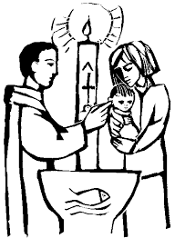
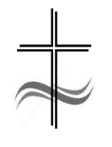

StowCaple Churches:

Baptism Application form

Please complete this form electronically and send it to stowcaple@gmail.com.
A member of clergy will then be in touch with you. Thank you.

Child/Children’s Details:
Child/Children’s Full Name:
Child/Children’s Date of Birth:
Fathers full Name: |  | Mothers full Name:
Mobile No: |  | Mobile No:
Email: |  | Email:
Home Address:
Home Telephone:
Father’s Occupation: |  | Mother’s  Occupation:
Has the father been baptised: |  | Has the Mother been baptised:
Has the Father been confirmed: |  | Has the Mother been confirmed:

Godparents details:
Full Name (1):
Address:
Email:
Are they baptised: |  | Are they confirmed:

Full Name (2):
Address:
Email:
Are they baptised: |  | Are they confirmed:

Full Name (3):
Address:
Email:
Are they baptised: |  | Are they confirmed:
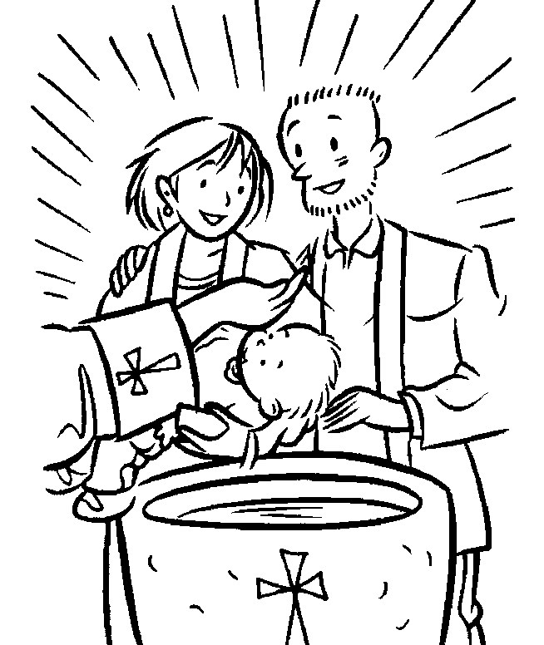

Additional Information:

Which church are you looking for the baptism to take place in:

Do you have some dates in mind for the service:

Is there any additional information that you think it might be helpful for us to know:

By signing this form, I/we am/are giving permission for the clergy to use your data in accordance with the Church of England’s General Data Protection Policy. Further information can be found on the Church of England website.

Signed(*):
Dated:

(*) Please type your name in the space provided.

If you have further questions, please do let us know. Thank you.

